Accessready.org And Top Tech Tidbits Announce Their Partnership to Provide Current Assistive Technology News and Trends to Their Joint Readership

Released: 1/17/2022

Authors: Douglas George Towne, Chair and Chief Executive Officer, Access Ready, Inc. and Aaron Di Blasi, Publisher, Top Tech Tidbits
Share to Facebook

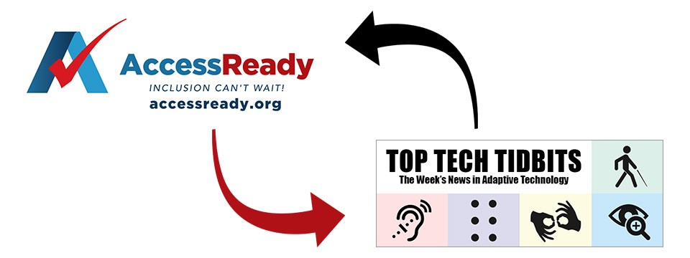

Access Ready Inc., a nonprofit cross disability advocacy organization promoting a policy of inclusion and accessibility across information technology through education and best practices has partnered with Top Tech Tidbits, the world's #1 online resource for current news and trends in adaptive technology.

Adaptive Technology refers to items that are specifically designed for people with disabilities. Adaptive Technology is a subset of Assistive Technology. Adaptive Technology often refers specifically to electronic and information technology access.

Founded in 2018, Access Ready publications reach out to over 100,000 professionals in the business, government, nonprofit and media sectors each month.

Sign up and review the archive at https://accessready.org.

The international advocacy organization promotes and advocates for an Access Ready environment across the business, government and nonprofit sectors.

An access Ready Environment is where access for people with disabilities at the physical and technological levels is a matter of forethought, design, inclusion and planning instead of a condition of afterthought, delay and discrimination resulting in risk to all concerned.

Founded in 2004, Top Tech Tidbits is a leading, not-for-profit, Adaptive Technology publication that reaches over 7,000 assistive technology professionals, educators and enthusiasts each week. Top Tech Tidbits is a sponsor and reader supported publication. The Top Tech Tidbits newsletter itself is released via email and social media every Thursday morning at 4:00 AM ET.

Sign up to receive it at https://toptechtidbits.com/subscribe and review the archive at https://toptechtidbits.com/.

Beginning January 17th, 2022, AccessReady.org, which publishes the daily Access Ready Monitor news wire, as well as the monthly Access Ready Reporter newsletter, will begin providing its readers with current news and trends in adaptive technology sponsored by Top Tech Tidbits. "As the leading provider of assistive technology news and information in the world we are pleased to have Tidbits on board and pleased to provide our readers with this new and valuable source of always current AT news and trends." stated Douglas George Towne, Chair and CEO of Access Ready.
In turn, beginning in January 2022, Top Tech Tidbits will begin including the monthly Access Ready Reporter newsletter within its closest weekly issue, providing its 6,900 weekly subscribers with new and current information that spans the disability spectrum, from advocacy to healthcare to government and more.

"It is our sincerest hope that both AccessReady.org readers as well as Top Tech Tidbits readers will benefit from this new publishing partnership." stated Aaron Di Blasi, Publisher for Top Tech Tidbits.

If you have questions, we have provided media contact information below.
Thanks so much for reading. We look forward to keeping you informed.

Media Contacts:

Access Ready
Douglas George Towne, Chair and Chief Executive Officer
Email: chair-ceo@accessready.org ✉
Web: https://accessready.org/ 🌐

Top Tech Tidbits
Aaron Di Blasi, Publisher
Email: ad@mvsltd.com ✉
Web: https://toptechtidbits.com 🌐

