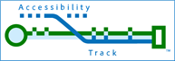
Accessibility Track

We help people in the accessibility and technology field improve conditions:
The world remains largely inaccessible to people with disabilities.
The way things are needs to change, and we are here to help you deliver better conditions for people with disabilities, for yourself as a an accessibility practitioner, and for your clients who are trying to do the right thing.
How we help:
Testing professionals have come to a shared understanding that there is an urgent need for standardized means of conveying how accessible a given technology is. Consumers and those in businesses need better information in order to make better purchasing decisions. Accessibility Track is leading the creation of a new community to develop standard accessibility reporting methods.
We provide a forum for discussion of ideas and solutions by those working to make technologies more accessible. Our two annual conferences are the ICT Accessibility Testing Symposium and the Digital Accessibility Legal Summit. We provide these tightly focused conferences to meet the information gathering and sharing needs of practitioners in testing, management of accessibility testing programs, and the legal field.
Accessibility Track provides expertise in the form of consulting on technology and accessibility testing. We also provide services to help you make accessibility a part of your corporate culture and practice.

standardari.org · ictaccessibilitytesting.org · accessibility.legal
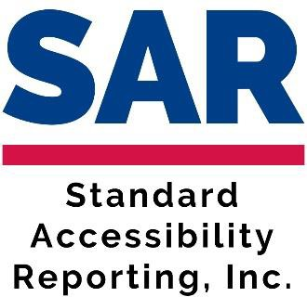
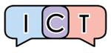


Chris M. Law · +1-443-955-0955
accessibilitytrack.com · chrismlaw@accessibilitytrack.com Copyright © 2023, Accessibility Track Consulting, LLC

