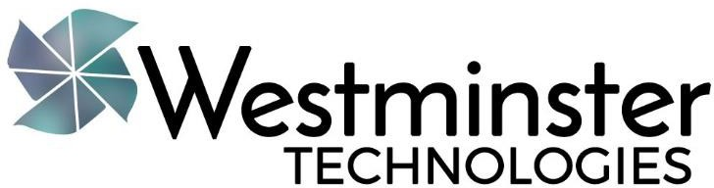

Westminster Technologies offers products and services to support special education teachers and therapists in their efforts to make a difference in the lives of their students.

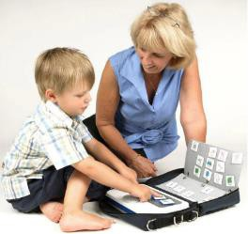Our product offerings include accessibility devices, communication tools, low vision solutions, software, learning tools and so much more. Explore our products at https://www.westminstertech.com/collections/all

Our services include assistive technology assessments and training:

- AT Assessments are offered as a onetime service or contractually and can be done at your location or remotely via video conference.

- 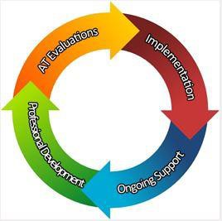AT Training is customized to your specific needs and can be conducted in-person, remotely, or self-paced online.

Westminster Technologies is a one-stop Assistive Technology Solutions Provider! www.westminstertech.com

www.westminstertech.com 216.325.6960 info@westminstertech.com

