25% OF AMERICANS
70% UNEMPLOYMENT
Is this the future we want for Americans with disabilities?
HAVE A DISABILITY!
Help the future - do not leave us behind!

82 MILLION AMERICANS

Are Depending on Accessible Information Technology!

Access Ready Inc. shall make the results of its technical ﬁndings, policy discussions, and advocacy efforts available to the public through accessready.org, its social media stream and other public relations efforts.

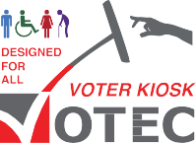

Sponsored by Access Ready Inc.
7780 49th Street North, Suite 425 Pinellas Park, FL 33781
(727) 531-1000
votecdesignedforall.com accessready.org
The Board of Directors of Access Ready has deemed
inaccessible information technology to be a clear, growing and present danger to the civic, economic and social welfare of people with disabilities.

We would welcome your support.

What is an Access Ready Environment?
In short, an Access Ready Environment is where accessibility is a forethought and not an Afterthought.

The clock is running and it’s running fast.

Buildings are built accessible, why not information technology?
What is an Access Ready Environment?
In detail, an Access Ready Environment is where access for people with disabilities at the physical and technological levels is a matter of forethought, design, inclusion and planning instead of a condition of afterthought, delay and discrimination resulting in risk to all concerned.

It’s about saving money.
It’s about the cost of the future. It’s about policy not legal action!

Access Ready Inc. is a non-proﬁt cross disability education and advocacy organization promoting a policy of inclusion and accessibility across information technology through education and best practices.
Accessibility is not only the absence of barriers, but must be bolstered by the presence of inclusion. The acceptance of exclusion anywhere is a threat to inclusion everywhere.
Inclusion Can't Wait!

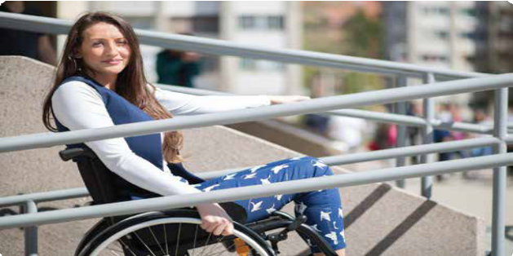
accessready.org accessready.org

